# **Principal Support Form**

**K12 Engineering Scholars Program**

|  |  |  |
| --- | --- | --- |
|  | **Summer, 2018** |  |

Dear Principal,

A teacher on your campus is applying to become a K12 Engineering Scholar.

K12 Engineering Scholars is an innovative professional development program for 4th-8th grade Science, Technology, Engineering, and Math (STEM) teachers in Washington State. The program begins with a six-week summer experience, during which teacher participants will:

# **Timeline**

• • •

**March 19 - Applications due**

**March 30 - Applicants notified of their status**

**July 9 - August 17 - Summer workshop on UW campus, weekdays only, 9am-4pm**

**TBD - Monthly meetings (in person or virtually) October 2018-June 2019**

* Collaborate on a vision to use real-world engineering and Next Generation Science Standards (NGSS) to enhance their current curriculum and enrich student outcomes;
* Be immersed in cutting-edge engineering research;
* Develop curriculum adaptations to engage and inspire their students;
* Design makerspaces to support student learning on their home campuses; and
* Create relationships with engineering and education colleagues across the region.

Participating Teachers will receive:

* $2,000 materials stipend per year per participant to support purchase of makerspace equipment; and
* $8,000 participant stipend per year to support participation in the summer experience and the academic year resource program.

Research indicates that students of participating teachers will:

* Experience real-world engineering scenarios and examples;
* Deepen their ability to use NGSS engineering practices;
* Explore their creativity in on-campus makerspaces; and
* Aspire to education and career pathways that include engineering and STEM fields.

Because we know that your support is essential to the success of your teacher’s participation in this program and the impact it will have on your students, we are asking you to complete this form.

To learn more about the project, please visit

<http://www.engr.washington.edu/future/k12/k12engrscholars>

If you have questions or need more information, please contact Jen Eklund, [Jen.Eklund@systemsbiology.org](mailto:Jen.Eklund@systemsbiology.org), (206) 732-2123.

Thank you,

K12 Engineering Scholars Leadership

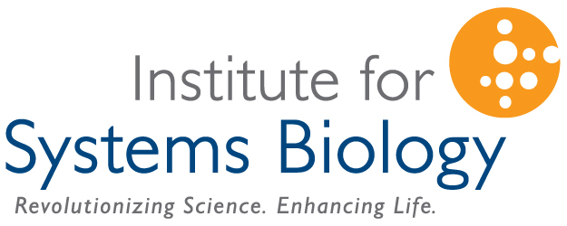This project is a partnership between the University of Washington College of Engineering and the Institute for Systems Biology’s Logan Center. This material is based upon work supported by the National Science Foundation under Grant No. 1542228. Any opinions, findings, and conclusions or recommendations expressed in this material are those of the author(s) and do not necessarily reflect the views of the National Science Foundation.

|  |  |
| --- | --- |
| Name of participating teacher(s) |  |
|  | |
| Your Name |  |
| Phone Number |  |
| School |  |
|  |  |
| Do you have any reservations about this teacher participating in this project:  yes  no  If yes, please explain: | |
|  | |
| In what ways might this experience contribute to your school’s culture and/or vision? | |
|  | |
| How might you leverage this experience to lead for science education? | |
|  | |
| How will you support this teacher in growing their own instructional practice and/or as a potential teacher leader? | |
|  | |
| Comments (*please share any other information you think is important*): | |
|  | |
|  | |
| Please return the completed form to the applying teacher, or mail or email to:  Email: [Jen.Eklund@systemsbiology.org](mailto:Jen.Eklund@systemsbiology.org)  Mail: Jen Eklund  Institute for Systems Biology  401 Terry Ave N.  Seattle, WA 98109 | |