Application

Timeline
• • •
March 19 - Applications due
March 30 - Applicants notified of their status
July 9 - August 17 - Summer workshop on UW campus, weekdays only, 9am-4pm:
  - Week 1 - Orientation
  - Week 2-5 - Lab Intensive - UW College of Engineering, Makerspace
  - Week 6 - NGSS engineering lesson(s) development

TBD - Monthly meetings (in person or virtually) October 2018-June 2019

K12 Engineering Scholars Program
Summer, 2018

Components of the Application Materials include:
Program overview – pages 1 & 2
Teacher application – pages 3 & 4 – can be completed in MSWord or printed and completed in pen
Principal Support Form– separate form

Completed application materials should be sent via email or mail no later than Friday, March 19, 2018:
Email: Jen.Eklund@systemsbiology.org
Mail: Jen Eklund
Institute for Systems Biology
401 Terry Ave N.
Seattle, WA 98109

Applicants will be notified of their participation status via email on March 30, 2018.

To learn more, please visit
http://www.engr.washington.edu/future/k12/k12engrscholars.

If you have questions or need more information, please contact Jen Eklund, Jen.Eklund@systemsbiology.org, (206) 732-2123.

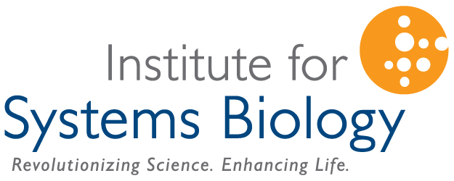

Program Overview

K12 Engineering Scholars is an innovative new professional development program for 4th-8th grade Science, Technology, Engineering, and Math (STEM) teachers in Washington State. The program begins with a six-week summer experience, during which teacher participants will:
- Collaborate on a vision to use real-world engineering and Next Generation Science Standards (NGSS) to enhance their current curriculum and enrich student outcomes;
- Be immersed in cutting-edge engineering research;
- Develop curriculum adaptations to engage and inspire their students;
- Design makerspaces to support student learning on their home campuses; and
- Create relationships with engineering and education colleagues across the region.

Participating Teachers will receive:
- $2,000 materials stipend per year per participant to support purchase of makerspace equipment; and
- $8,000 participant stipend per year to support participation in the summer experience and the academic year resource program.

The Benefits in the Classroom:
Your students will:
- Experience real-world engineering scenarios and examples;
- Deepen their ability to use NGSS engineering practices;
- Explore their creativity in on-campus makerspaces; and
- Aspire to education and career pathways that include engineering and STEM fields.

Who should apply:
Applications will require that teachers:
- Actively teach science and/or STEM in one or more targeted grades 4 – 8 (Librarians will be considered if they apply as part of a team that includes a teacher);
- Commit to the attendance and time requirements of both the summer experience and academic year resource program; and
- Commit to develop NGSS-aligned curriculum enhancements that they will share broadly with other teachers/schools/districts.
Priority will be given to:
- Teams of two from a single school
- Teachers from high-needs schools

This project is a partnership between the University of Washington College of Engineering and the Institute for Systems Biology’s Logan Center. This material is based upon work supported by the National Science Foundation under Grant No. 1542228. Any opinions, findings, and conclusions or recommendations expressed in this material are those of the author(s) and do not necessarily reflect the views of the National Science Foundation.

Contact information
Name
Home address |  | Home Phone
 |  | Cell Phone
 |  | Home Email
Professional information
School |  | School Phone
School District |  | School Email
Grade level(s) taught |  | Principal
Curriculum/kits used
Name of any colleagues at your school who are also applying (Preference will be given to teams of 2 from a single school)
I will be available for the entirety of the summer workshop: yes no
If no, please explain:

In general, I will be available for monthly meetings (in person or virtual): yes no
If no, please explain:

Personal Statement
Why are you interested in participating in this project? What do you hope to achieve?
Describe any experiences you’ve had incorporating engineering into your classroom previously - what was successful and what were the barriers?
Describe any experiences you’ve had creating or adapting standards-based curriculum (using NGSS or other standards)- what was successful and what were the barriers?
Tell us about your students (beyond demographics numbers) and how they might benefit from your involvement with this program.
The principal support document is
being submitted with this document.
being submitted directly by my principal.
Other, please explain:

Comments (please share any other information you think is important):

