**Project:**

Projected send date:



# File Structure

* Program is located in the correct Marketing Initiative Folder. *In the example on the right, Engr-CoE-Trend is a Marketing Initiative Folder.*
* The 3 standard Program Folders are nested under the Program (Assets, Reports, Smart Campaigns).
* All program components are organized within the correct Program Folders.

# Program Name

* Program Name is unique and follows prescribed naming convention. For example:

***Engr-FYyy-Unit-Type-ID-Description****Engr-FY18-CoE-5888-Trend-Spring2018*

* + ***Engr*** *– for all UW Engineering workspaces*
  + ***FYyy*** *– fiscal year identifier: FY19*
  + ***Unit*** *– CoE, ME, EE, etc.*
  + ***Type*** *– (We haven’t been using this. Only one UW is using for now is EM for email.)*
  + ***ID*** *– The Program ID is a unique, 4-digit number Marketo uses to identify a program. First you create the program, then you find the unique Program ID in the url of the program and update the Program Name.*
  + ***Description*** *-- A recognizable, meaningful description of the program for your team’s purposes. For example, Trend-Spring2018*
* Program ID is updated and matches the URL of the Program. *For example, in the url* [*https://app-sj19.marketo.com/#EBP****5888****A1*](https://app-sj19.marketo.com/#EBP5888A1) *the Program ID is shown in bold.*

# Tags

* The defined Channel correlates to the correct type of communication.  
  *In Marketo, click the program name, and click the* ***Setup*** *tab. Check the* ***Channel****,* ***Purpose****, and* ***Subscription Name*** *tags.*
* The designated Tags are appropriate for the program. *Tags are general descriptions for the email. For example, in Target Audience, Alumni is just an indicator of the general recipients of the message, not the name of the audience list.*
* The **SubPref tag** (for example, *ENGTrend*) is populated and reflects the correct Subscription Preference for this communication.

# Audience

Confirm that the correct audience is appended and that the Audience section of the Control Panel shows a reasonable approximation of the expected number of recipients.

# Schedule

* The email is scheduled for the correct date and time. *This example shows a sent message, but look for the schedule info on the Control Panel view of the program.*

# List Review

* Confirm Smart List has the correct list selected for “Member of List.”
* Confirm Smart List excludes the correct Subscription Preference.

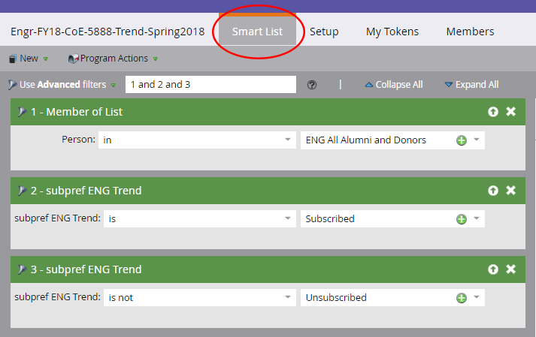

# Calculate Audience

* Verify that audience size matches the estimated size of your original list.
* View List and spot check that members are accurate.



# Accessibility

* Link styles are correct.
* Link text is descriptive and unique.
* All Images have meaningful Alt-Text populated.

# Email Settings/Actions

* Pre-header is enabled and populated with meaningful text.
* “View as Webpage” is enabled.
* Email has been approved and subject line is populated.

# Formatting

* Formatting has been stripped from all text that has been copied from a different source.
* Plain Text has been reviewed and formatted for readability.

# Images

* Image modules are populated with correctly sized images.

# Links

* All links begin with http:// or https://
* All linked email address are formatted with mailto: prefix.

# Footer

* Contact Us email is populated and uses the mailto: prefix.
* Social media icons are linked to the appropriate sites.
* Copyright and Address are correct.
* All above text and links **– the unsubscribe link in particular –** have been copied to the Text version of the message.